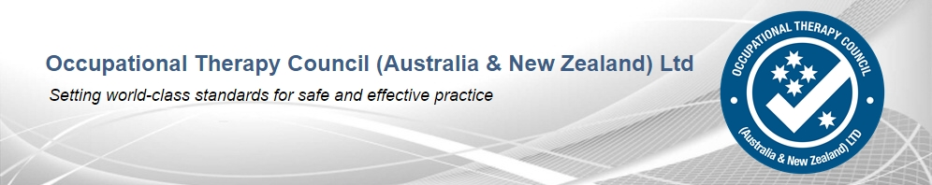

COMMUNIQUE No. 23

August 2018

The OTC directors met via teleconference on 13 August 2018. The following items formed part of the agenda:

Program Accreditation Committee (PAC)

A busy schedule of program accreditation continues for 2018. Since the previous OTC meeting in April 2018:

- One accreditation recommendation has been approved by the OTBA.
- Two accreditations recommended are pending approval by the OTBA.

Looking ahead to next year, we have:

- Four site visits scheduled for the remainder of 2018.

Overseas Qualification Assessment Committee (OQAC)

- An article to encourage more registered occupational therapists to assume a supervisory role for overseas-trained practitioners seeking general registration was included as a centre page editorial in the April 2018 edition of Occupational Therapy Australia’s Connections Magazine.
- Policies and procedures for all aspects of qualification assessment, including application and review/appeal mechanisms continue to be reviewed to maintain currency.

Governance and Strategic Affairs Committee (GSAC)

- Strategic planning was undertaken in April 2018; consolidation of the outcome from the planning continues to be refined.
- Risk management will be reviewed on a regular basis.

Health Professions Accreditation Collaborative Forum (HPACF)

Assoc Prof Adamson attended the Forum meeting in Melbourne on 13 July 2018. This meeting was hosted by the OTC. The Forum continues mapping its strategies and priorities for the year, including information relating to cultural capabilities (an area being addressed by the OTC), safe use of medicines, and interprofessional standards.

Accreditation Standards

The review of the accreditation standards is progressing as scheduled. The revised accreditation standards are available for public consultation and available on the OTC’s website.

National Registration and Accreditation Scheme activities

It was noted no further information has been received regarding the 2017 Accreditation Systems Review. It is anticipated the report may be included in a future COAG Health meeting.

Occupational Therapy Board of Australia
The OTC has provided responses to consultations relating to:

Supervised practice framework
Review of registration standards
Support of equity health for Aboriginal and Torres Strait Islanders was also provided.

***

