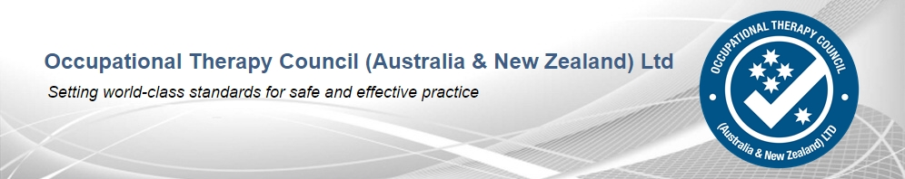

COMMUNIQUE No. 20

November 2017

The OTC directors met face-to-face in Adelaide over the weekend of 10 to 12 November 2017. The following items formed part of the agenda:

Website

There will be on-going maintenance of the website to ensure currency of information and simplicity of navigation.

Program Accreditation Committee (PAC)

A busy schedule of program accreditation was set for 2017. Since the previous OTC meeting in April,

- Three accreditation recommendations have been submitted to, and approved by the OTBA in the period since the previous OTC meeting.
- Four accreditations recommended are pending approval by the OTBA.
- One site visit is scheduled for the remainder of 2017.

Looking ahead to next year, we have:
- Six site visits scheduled for 2018.
- Assessor training is currently being planned and will be conducted early in 2018.

Overseas Qualification Assessment Committee (OQAC)

- The revised timing for the Stage 2 period of supervised practice is working well.
- Policies and procedures for all aspects of qualification assessment, including application and review/appeal mechanisms will be reviewed to maintain currency.

Governance and Strategic Affairs Committee (GSAC)

- Strategic planning has been scheduled for April 2018.
- Risk management will be reviewed on a regular basis.
- Board evaluation will be undertaken at the conclusion of each face-to-face meeting.
- A skills matrix will be developed to ensure a balance of experience is represented on committees.

Health Professions Accreditation Collaborative Forum (HPACF)

The Forum meeting held in Canberra on 15 September 2017 was attended by Ms Jan Erven and Mr Bradbury.

Assoc Prof Adamson and Mr Bradbury attended a special Forum meeting in Melbourne on 14 November 2017 to discuss the draft report of the review of the National Registration and Accreditation Scheme. Professor Woods and the Review team were present to discuss recommendations with Forum members.

Accreditation Standards

The review of the accreditation standards is progressing as scheduled with an estimated completion date of mid-2018. The process will map out stakeholder engagement, following guidelines established by OTBA. The steering committee has met twice and the reference group once since the last meeting of the directors in July 2017. Consultations will be sought from internal and external stakeholders commencing early 2018.

National Registration and Accreditation Scheme activities

Activities in relation to the review of the Scheme will be monitored by the OTC, which looks forward to submission of the final Review report to COAG.

Meetings with external stakeholders
The Board welcomed the opportunity to meet with representatives of OTBA and OTA to ensure processes managed by OTC are functioning satisfactorily. Discussion with partners is an essential element of ongoing development of the work of the OTC.
.
***

